**85 points**

**Name: Fabian LeFevre**

**Date: 1/21/19**

**Homework 1:**

1. Paste the two screenshots from above here. (40 points)

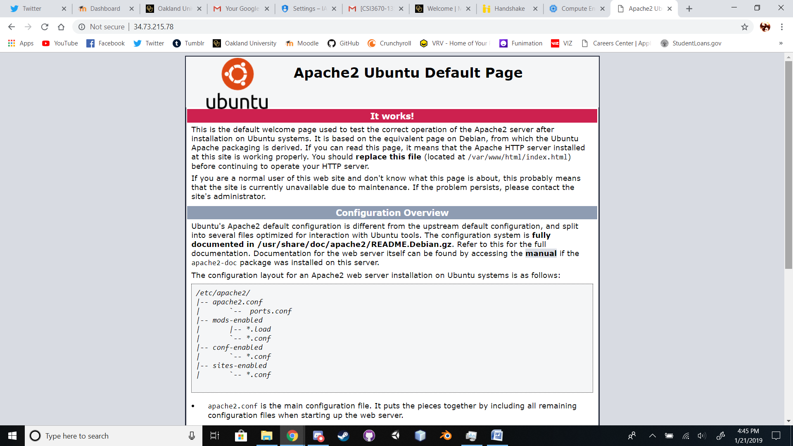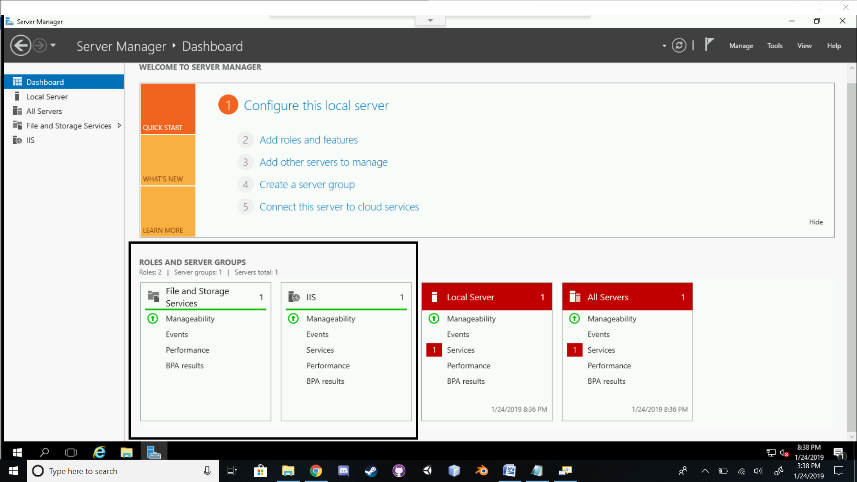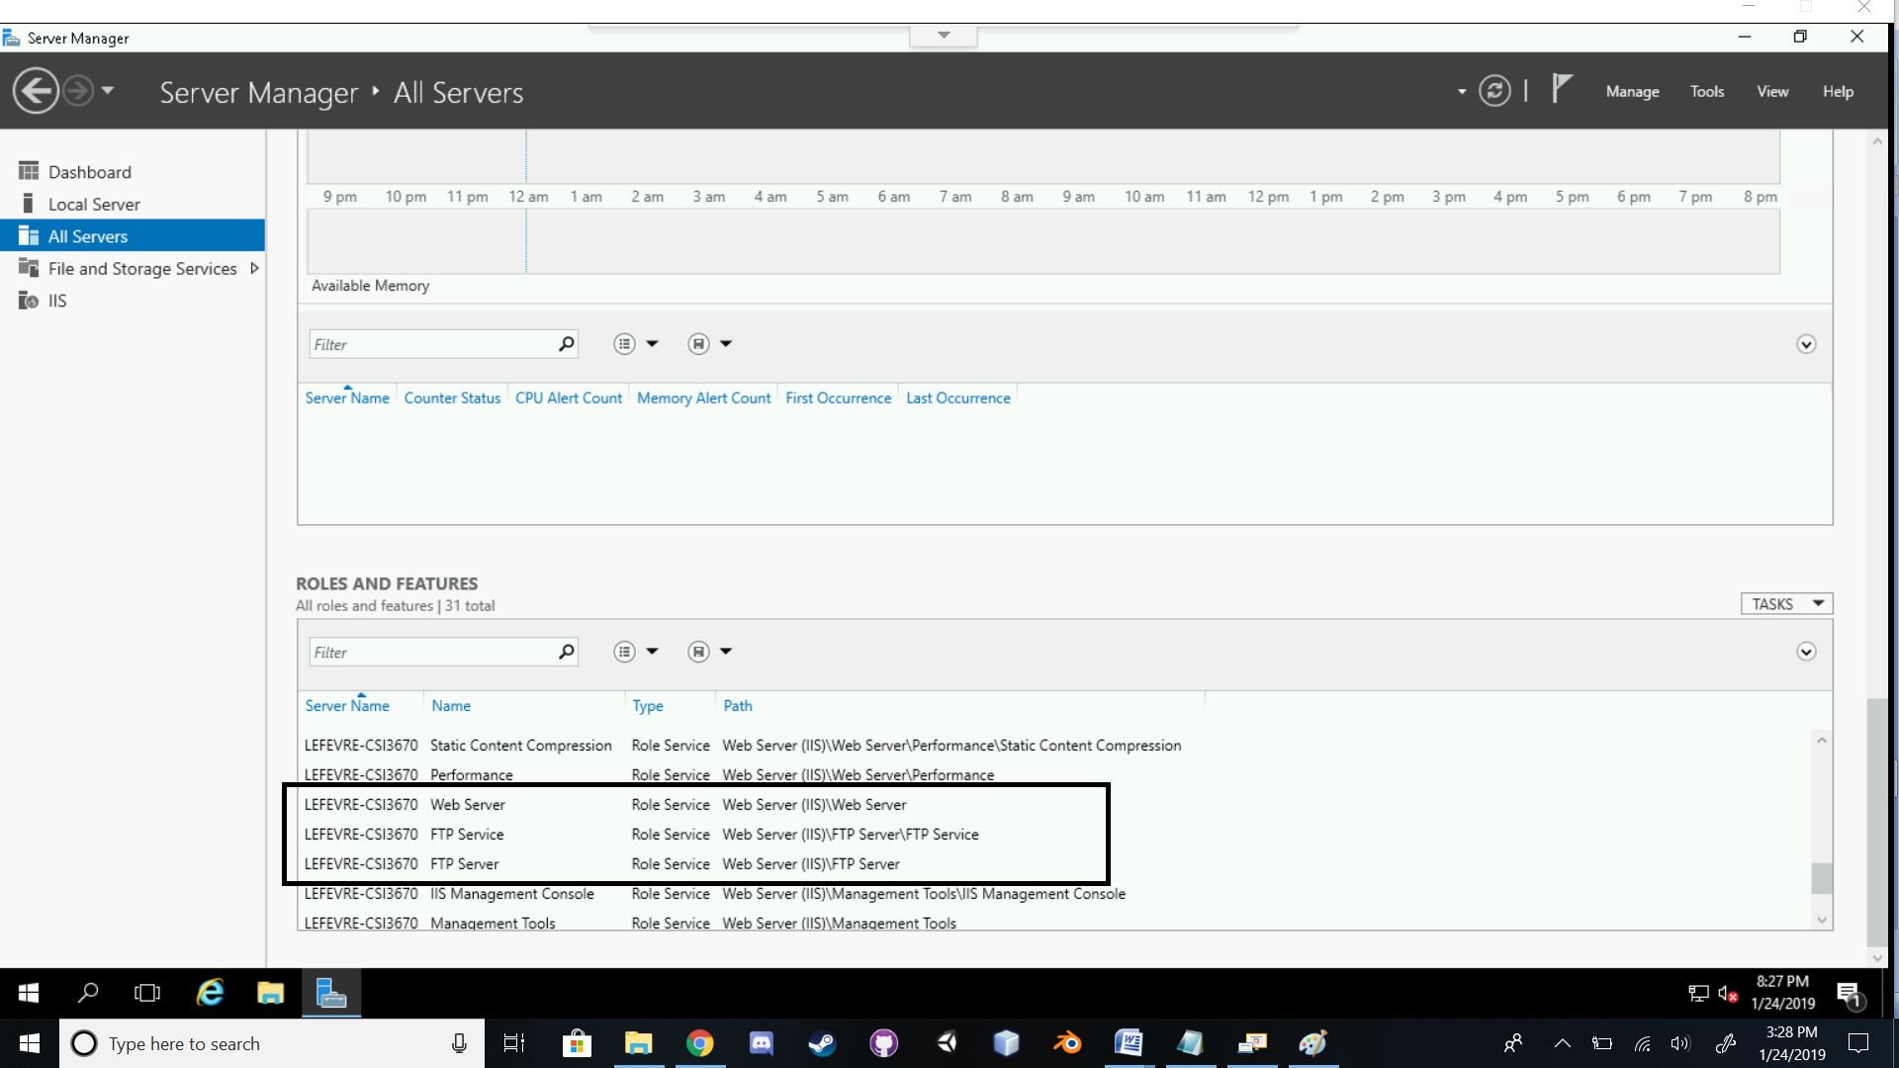

1. Go to <https://cloud.google.com/products/> and pick **2** random Google products that are available in their cloud platform (meaning, you have access if you wish). Briefly describe (1) what it is and (2) why it might be helpful. **Do not simply just copy and paste the descriptions.** (10 points).

**1 – Analytics and Machine Learning**

**Product that provides services for analyzing a large variety of data, as well as, services for machine learning to create or utilize AI for handling video, application, and image processing and decision making.**

**This is good for programs or systems that need to parse a lot of data and for programs or systems that need to process that data in order to make decisions.**

**2 – Collaboration and Productivity**

**A suite of software and services provided by Google(Gmail, Hangouts, Google+, Drive, Docs, Slides, etc). Also, provides admin and other management services.**

**This is helpful for creating and managing documents, apps, and access. Oakland University uses this Suite on its website and mobile app.**

1. Assume you are installing Windows Server 2012. Provide two reasons for selecting one version over another. For example, why would you want to install the Foundation edition over the Datacenter edition? Why would you want Standard over Essentials? (10 points)

**I would choose Datacenter because it provides everthing that all the other versions have and is useful for virtualized environments.**

1. Look over some of the available roles that Windows Server provides. Select two and describe their purpose. (10 points).

**Active Directory Certificate Services – Service that provides certificate management for certificates used by several applications. Also used to create certification authorities.**

**Network Controller – Provides automation necessary for continual configuration, monitoring and analysis of Network utilities, services, hardware, software, the virtual/physical networks, etc. Acts as a Datacenter.**

1. What is the difference between Type-0 (full) and Type-1 (para) virtualization? (10 points)

**Full virtualization makes the OS believe it is utilizing physical hardware and is the most secure of the two types.**

**Paravirtualization uses less overhead, makes it easier to modify the kernel of the OS, and the guest (dom0) utilizes the real hardware for all the other guests.**

1. What is the IP address of your Ubuntu virtual machine? (5 points)

**34.73.215.78**